Welcome to our Program!

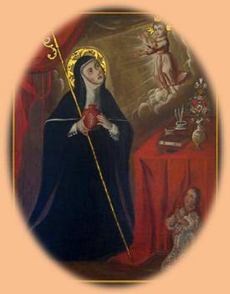
St. Gertrude
Both Brian and I would like to offer the fruits of our work for our immediate family members who have passed from this life, especially his father Thomas Bagley, my father Stephen W. Humphrey Jr. and my mother, Dorothy Humphrey.
It would be greatly appreciated if you send me an e-mail confirming that your received your FREE Purgatory Prayer Program.
You can reach me at mike.hump@comcast.net .
After reviewing our Program, if you like what you see, are well off financially, and interested in supporting our work, please see the last section of this hand-out at the end:
Interested in financially supporting our work?

If you can’t support our work, don’t worry. All we ask is that you use our prayer program materials in a useful way as part of a current or future prayer meeting in your area.

Thanks for your interest and let’s keep in touch!
Mike Humphrey and Brian Bagley,
Send your feedback to Mike Humphrey @ mike.hump@comcast.net.
Check out my other work too @:

http://www.AskACatholic.com
http://www.AskACatholic.com/ScripturePassages
and
http://www.BibleBeltCatholics.com

Mike Humphrey

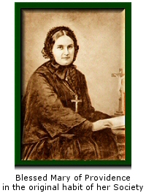
Welcome to our
Apostolate of Purgatory!

Dear Purgatory Prayer Warrior,
Both Brian and I would like to welcome you to our Helpers of the Holy Souls Prayer Program!

We think the work of praying for the Holy Souls in Purgatory has been overlooked for way too long.
As stated on our home page HelpersOfTheHolySouls.com:

Helper of the Holy Souls is inspired by Blessed Mary of Providence and the original mission of the Order she founded in 1856, Society of Helpers of the Holy Souls.
Our mission, one of mercy, is to relieve and gain release for the suffering souls in Purgatory who can no longer help themselves.

Enclosed you will find a paper version of our prayer program in English. If you are interested in a similar Purgatory Prayer Program in other languages, check out our web site by going to
Start your own > Download the Free Program! <On the left side bar>

We have the Program in six other foreign languages: Spanish, Portuguese, French, Italian, German, and Polish. If you are disappointed with any translation and wish to help provide a better one, just e-mail me a better translation.

We would encourage and recommend that you use your local paper store, (Staples, Office Max, Office Depot) and Print Shop or whatever is near you to create multiple copies of your Purgatory Prayer Programs using the attached set of Purgatory Prayer Program Supplies Sheets. They can also help in re-creating the enclosed Holy Cards as there is no copyright on these cards.

Though the outline of the program can be found on the Suggested Holy Hour Order of Prayer card, you are more then welcome to change any portion of it according to your time, desires, and interests and make it YOUR Purgatory Prayer Program for the Holy Souls.
The vision of this program was not to receive feedback like: “Can we have ## more packages?”
The Program was designed to be an autonomous one; one that, God-willing, will be perpetuated to your friends, family, parish, diocese, and beyond. As I said, the needed supplies for this Purgatory Prayer program can be found in the attached supply sheets.
We encourage you to work as a group to customize, reproduce, and buy the supplies required to replicate this Prayer Program using the information in the attached set of Supply sheets.
Check out the benefits of a “at home” prayer program at:
http://www.helpersoftheholysouls.com/waystohelp/StartYourOwnPrayerProgram.htm
We have found that some participants have initially started our program as a private prayer devotional, before bringing it to their pastor for a possible regular prayer program within their parish. For Deacons and Priests who have asked for a program, we suggest talking to their bishop about offering this, or a similar program, at a diocesan level.
When talking with friends and family on Purgatory, it’s important they know the basics:
- Purgatory is not a third place along with Heaven and Hell nor is it a second chance.
- Purgatory is like the Holy Hospital of Heaven.
- Souls in Purgatory have been saved just as much as the souls in Heaven.
Think of sin as a self-inflicted wound in your life.
When we physically hurt ourselves, many times we have to be brought to the hospital and the doctor or nurse will put an alcoholic disinfectant in our cut or wound. It will hurt ... a lot!!! but it's a good hurt; it's a holy hurt, that is needed to make us physically better and to make us physically whole and pure.
We also have to distinguish between less severe physical injures where we cut ourselves and require stitches and more severe injures, like a NASCAR racing driver who gets into a major collision and ends up with third or fourth-degree burns over 90 percent of their body. There are varying degrees of damage that we do to our bodies, not only physically, but spiritually too!
Because Revelation tells us that nothing impure can enter Heaven (Revelation 21:27) and because
God Himself is all Holy, we too, have to be all Holy to enter Heaven. To achieve this, any remaining
self-inflicted spiritual wounds or self-love from our pilgrimage on earth has to be healed or burned off.
If our spiritual injures are along the line of “just needing stitches”, that healing period where our
self-love has to be burned off may be short; but if our self-inflicted injuries are along the line of third
or fourth-degree burns, the healing process may take longer. Saints have had private revelations from the souls in Purgatory who share that while the [healing | burning] fires of God’s Love in Purgatory are painful (Hebrews 12:29, Exodus 3:1-6) at the same time they had an internal burning joy because they knew they were being conformed to the image of God and their final destiny would be total union with Him.
Instead of the good healing pain that the alcoholic disinfectant gave us under a doctor’s care to prepare us to re-enter the earthly world again, in Purgatory, we experience a holy, healing pain under Jesus’ Care which purifies our souls and prepares us to enter eternal life with God who is all Holy. Think of the number of people who have passed from this life to the next since 33 A.D., many with major spiritual injuries.
There are a lot! This is why praying for the Holy Souls in Purgatory is very important – and they can’t wait for Heaven!
P.S. Remember to contact me if you change your e-mail address.
I can’t provide updates to you and new ideas if we don’t keep in touch.
Mike
@ mike.hump@comcast.net
Ways to help the
Holy Souls in Purgatory!
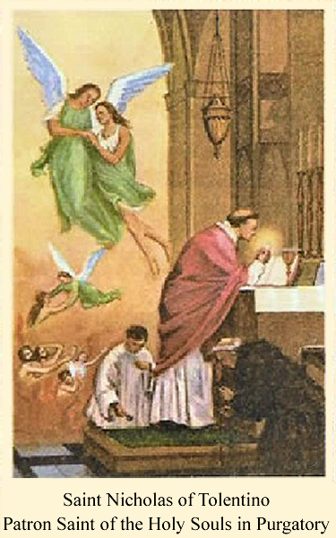

14 Ways to help the Holy Souls in Purgatory

- The best way to help is to have the Holy Sacrifice of the Mass offered up for them ¹ or devoutly assist at Holy Mass for their relief.
- Make the Stations of the Cross for their consolation.
- Pray the Holy Rosary of the Blessed Virgin Mary for them.
- Gain indulgences for them ²
- Offer up pains, self-denials and sufferings for their relief.
- Pray, offer up works of mercy and practice virtues for their consolation.
- Ask the Blessed Mother to choose an unknown soul for you to pray for.³
- Lovingly sprinkle Holy Water, in faith and with trust, for their cleansing.
- Light their darkness, as an act of love, by burning a blessed candle for them.
- Liturgical prayers like:
  - De Produnis (Psalm 129 {Official prayer for the Holy Souls in Purgatory} , found in most Catholic prayer books.)
  - Pray the Office of the Dead or Vespers, the liturgical hours of the Church.
  - "Eternal Rest" prayer:
Eternal Rest grant unto them O Lord and let perpetual live shine on them and may the souls and all the souls of the faithfully departed rest in peace.
  - Prayers from the Roman Missal for the Souls in Purgatory.
Visit a Church or Chapel and spend some time in front of the Blessed Sacrament for their comfort and relief.
- Visit a Cemetery, and pick out a number of grave stones and say some prayers for their souls.
(From November 1st - 8th, a plenary indulgence can be obtained for the departed souls by devoutly visiting a cemetery and praying for the dead. Use the tombstone as a kneeler and pray the Rosary for your loved one.)
- START YOUR OWN PURGATORY PRAYER PROGRAM TODAY!
Finally:
- Organize collections for Masses for the Holy Souls.
Check out how we have organized our Masses for the Holy Souls Program in the next section.
1 All monthly donations to Helpers of the Holy Souls go to having Holy Masses offered up for the relief or deliverance of souls in Purgatory.
2 Catechism of the Catholic Church 1471-1479. The Handbook of Indulgences also may be consulted.
3 e.g, Rosaries, rosary decades, Stations of the Cross, special prayers, any merciful acts, etc.

Having Masses said for the Holy Souls.

Before explaining our organization and approach to having Masses said for the Holy Souls, let’s clarify some terms and possible issues people may have.

In training his disciples on bringing the Gospel to the world, Our Lord told his disciples in Luke's Gospel:

Go your way; behold, I send you out as lambs in the midst of wolves. Carry no purse, no bag, no sandals; and salute no one on the road. Whatever house you enter, first say, 'Peace be to this house!' And if a son of peace is there, your peace shall rest upon him; but if not, it shall return to you. And remain in the same house, eating and drinking what they provide, for the laborer deserves his wages; do not go from house to house. Whenever you enter a town and they receive you, eat what is set before you; heal the sick in it and say to them, 'The kingdom of God has come near to you.'

Luke 10:3-9

From this we clearly see that Our Lord believes in a just wage for the work of His new priests/disciples. The word the Church uses today for this is called a stipend. A stipend is a fixed pay, salary or retribution for work done; the income of an ecclesiastical living.

In order to have Masses offered up for the Holy Souls on a regular basis, we collect stipend money on a monthly basis. Is it something that's required? <No.> Is it something that is just? <Yes.> This allows us to have Masses said by priests who value this important, but sometimes overlooked, intention of the Universal Church. Stipend amounts for a Mass intention vary from parish to parish. Any objections to stipends as a money making machine can quickly be diffused as no priest is going to get rich over Mass stipends. In the Boston area, the suggested amount for a Mass stipend is usually about $10.00.

There are three (3) sources Brian uses to collect stipend money for our Mass intentions:
- He gathers empty cans and bottles from friends and family, who have no interest or use for them and redeems them at a local supermarket for cash.
- He gathers individual donations in multiples of $10.00 from friends and family who wish to have a Mass said for the Holy Souls.
- Finally, he gather "pocket change" from anyone one who can't afford to make a $10.00 donation. We call this part of our program "Pennies from Heaven."
During the calendar year, at most parishes, Mass is offered up for a particular intention on various days.
Brian calls or stops by the rectory to find out what Masses he can have scheduled to be said for the Holy Souls in Purgatory. How far in advance we can schedule a Mass will vary from parish to parish. An important key to doing this successfully is developing a good relationship with the personnel at the rectory.

Most of the time, stipend money collected in one month, is used to schedule Masses for the Holy Souls for the next month. What you can and can't do will vary from parish to parish and diocese to diocese.

Brian has a very organized method for keeping track of Masses he has scheduled.

As a means of organizing his efforts, he uses:
- a metal cash or security box
- a deposit bag — most retail stores use to bring their revenues to the bank
- a 8.5" x 11" yearly organizer (e.g. Day Minder, At-A-Glance) and
- a contact book
The metal cash or security box and deposit box are used to secure donations made by friends and family as well money collected from his empty bottles and cans program.

The yearly planner he uses can be bought at any Staples or Office Max. He uses this to keep track of the Masses he schedules at the various parishes.

His contact book keeps the names and postal addresses of Churches he has worked with along with phone number and contact names of the people he talked to.

It's our hope that sharing the way Brian has organized his apostolate will assist you in starting and developing your own.

Start Your Own Purgatory Prayer Program Today!
At Helpers of the Holy Souls, we offer a FREE start-up Purgatory Prayer Program that you can customize to your liking. It can be said as a private devotional in a chapel or church or be said as a monthly Catholic prayer meeting in a chapel, church, or even at someone's home.
I was involved in a monthly First Saturday prayer meeting for at least eight to ten years at a friend's home.
Monthly Catholic Prayer Meetings are a great way to:
- Pray for the Church Suffering as well as strengthening the Church Militant
- Confirm fellow Catholics in areas of the faith they may have questions about.
- Share common struggles and sufferings (as well as joys and successes) on home and work-related issues
- Meet new friends and connect with old acquaintances.

Usually after the prayer meeting, my friend's wife was gracious enough to have some coffee, soda and other snacks prepared.

HelpersOfTheHolySouls.com supports these types of Catholic prayer meetings as long as "the talk" before and after the prayer meeting is faithful to the Church.
Many times, conversation about unapproved Marian apparitions can arise or a "Gnostic environment" can develop:

e.g. "You are so privileged to know this information that the rest of the Church doesn't know."

If conversation or practices develop within the prayer meetings that are contrary to ANY paragraph of the Catechism of the Catholic Church or Church's Magisterium, you know it's time to leave. Prudence should be used in discerning whether the issues involved should be brought to the local bishop.

Purgatory Prayer Program Supplies Sheets
The following sheets give you the needed information so you can order more supplies for your Purgatory Prayer Program.

The only items in the Prayer Program that were custom-made by Helpers of the Holy Souls were the Holy Cards. Some of the contact information for the companies and religious organizations that supply the booklets, pamphlets, and other devotionals along with their cost may be out of date. For that reason, we would suggestion you Google the company and booklet name for the appropriate contacts, purchasing information, and cost information.

Staples® or similar Card Stock,  8 1/2" x 11", White, 250/Pack  Eye-catching, soft pastel colors!  - 110 Lb.  - 8 1/2" x 11"  - White, 92 bright  Item 490887  Model 49701  You can use this or a similar product to replicate most of the Prayer Program in the packet.  If you don’t have a “Paper store” where you live, you can write out the Prayer Program on any similar sheet of paper. Any nearby printer or Office store can cut the sheets as needed. |   $9.98 250/Pack
Novena & Chaplet to the Divine Mercy Leaflet  Divine Mercy Publications, Inc.  https://shop.divinemercyusa.com/main.sc  Item Number: L15  Order By Phone  954 578-3575 | 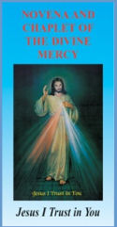
Monastery of the Precious Blood  5400 Fort Hamilton Parkway  Brooklyn, New York 11219-4037  (718) 438-6371 - Fax: 438-6381  http://www.sisterspreciousblood.org/  -----------------------------------------------  5.25” X 3.5” 2 page folder out  Novena to the Precious Blood  Sister Margaret Mary  Call and we will send them to you. | 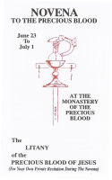
Our Lady of the Rosary Library  11721 Hidden Creek Rd.  Prospect, KY 40059  Phone (502) 425-9738  http://olrl.org/library/oform.shtml  ---------------------------------------------  Litany for the Poor Souls in Purgatory  3.33” X 5.5” | 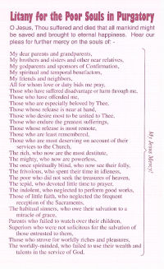
  Litany for the Poor Souls in Purgatory | 2¢ ea.
Item: L01  © Holy Face Association  P.O. Box 1000, Station A,  Montreal, Quebec, Canada H3C 2W9  P.O. Box 821,  Champlain, New York, USA 12919-0821  Telephone: (514) 747-0357,  Fax: (514) 747-9147  Date last modified: Sept 6, 2005  http://www.holyface.org  Holy Face Golden Arrow  Holy Face of Jesus 3 page pamphlet - explanation  Enter our site > On-line Store > Leaflets  100 for $3.00  1000 for $30.00 | 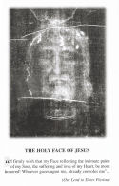
The Fourteen Stations of the Way of the Cross with Meditations  By St. Alphonsus Liguori  SKU: 14/05  ISBN: 978-0-89942-014-1  St. Jude Shop  Serving Christ in the World  https://www.stjudeshop.com  Order By Phone  888-640-0773  Saint Alphonsus Liguori's The Way of the Cross is a beautiful and reverent devotion to the Sacred Passion of our Lord, following Jesus along the Fourteen Stations of the Cross from His condemnation to death by Pontius Pilate, to His being laid in the tomb. | 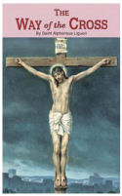  .  In full color with a flexible cover, The Way of the Cross is a devout meditation that allows readers to be prayerfully present to Jesus's Passion and sacrifice  30 Pages ~ 3 7/8" X 6 1/4"
TAN Books and Publishers, Inc.  P.O. Box 424  Rockford, Illinois 61105  Toll Free: (800) 437-5876  Direct: (815) 226-7777  Fax: (815) 226-7770  Email: customerservice@tanbooks.com  https://www.tanbooks.com/index.php/page/shop:prayercards/  -----------------------------------------------  How To Gain a Plenary Indulgence  100-400 - $7.50/100  500-900 - $5.00/100  1000-9,999 - $3.50/100  10,000 - $3.00/100 | 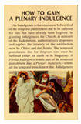
Pat Balderrama  St. Michael's Store  (909)829-1328  All Souls Novena  10 - $0.80/ea  100 - $0.65/ea  500 - $0.55/ea  1,000 - $0.35/ea | 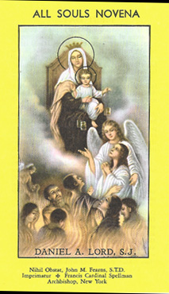
Daily Pilgrimage to Purgatory  Missionaries of the Sacred Heart  PO Box 270  305 S. Lake Street  Aurora, Illinois  60507  Telephone: 630-892-2371  Ask for Debby Camp  https://missionaries-of-the-sacred-heart-usa.myshopify.com/  All booklets are $3.00 each even in bulk!  Shipping and handling included in the price. | 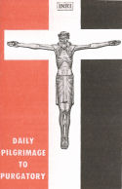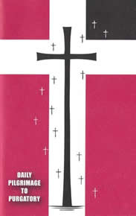
Prayer for the Forgotten Ones  Wholesaler: T. J. Peters Co. Prayer Cards  T. J. Peters Number: TJP 842  Retailer:  St. Andrew’s Book, Gift & Church Supply  305 West 8th Ave  Vancouver, BC, V5Y 1N6  Canada  Phone: 604-875-1441  Toll-free: 1-800-663-7161  Sold per 100. Boxed. $20.00  2-1/2" x 4-1/4" approximate size.  Please contact us for quantity discounts. | 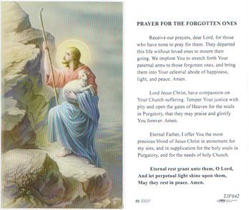
Prayer for the Souls in Purgatory  Wholesaler: T. J. Peters Co. Prayer Cards  T. J. Peters Number: TJP 731  Retailer:  St. Andrew’s Book, Gift & Church Supply  305 West 8th Ave  Vancouver, BC, V5Y 1N6  Canada  Phone: 604-875-1441  Toll-free: 1-800-663-7161  Sold per 100. Boxed. $20.00  2-1/2" x 4-1/4" approximate size.  Please contact us for quantity discounts. | 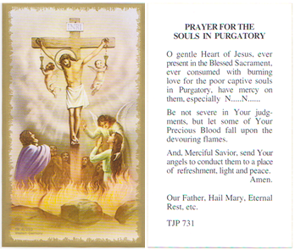
Blessed Mary of Providence  Holy Card  If you are interested in obtaining more of these holy cards, you should be able to create them with the help of a computer person or someone with a print background.  For all three Holy Cards and our Commitment Card, we would encourage and recommend that you use your local paper store, Staples, Office Max, Office Depot, or whatever store to re-create and duplicate these cards. Avery sometimes has paper print templates [like 8877 or 8371] that you can buy for this purpose. | 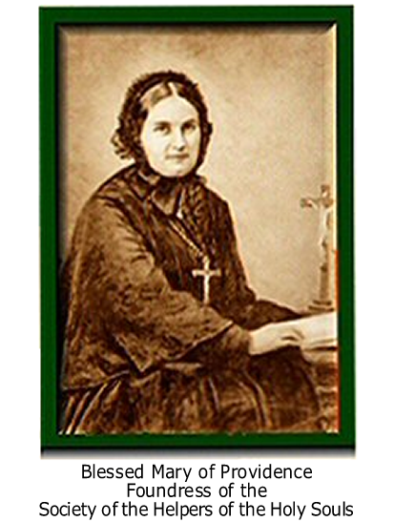
Saint Nicholas of Tolentino
Holy Card

If you are interested in obtaining more of these holy cards, you should be able to create them with the help of a computer person or someone with a print background.

For all three Holy Cards and our Commitment Card, we would encourage and recommend that you use your local paper store, Staples, Office Max, Office Depot, or whatever store to re-create and duplicate these cards. Avery sometimes has paper print templates [like 8877 or 8371] that you can buy for this purpose.
Our Lady Queen of Purgatory  Holy Card  If you are interested in obtaining more of these holy cards, you should be able to create them with the help of a computer person or someone with a print background.  For all three Holy Cards and our Commitment Card, we would encourage and recommend that you use your local paper store, Staples, Office Max, Office Depot, or whatever store to re-create and duplicate these cards. Avery sometimes has paper print templates [like 8877 or 8371] that you can buy for this purpose. |  | 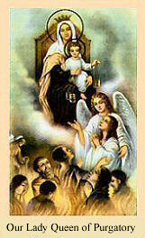
Helpers of the Holy Souls Commitment Card  If you are interested in obtaining more of these holy cards, you should be able to create them with the help of a computer person or someone with a print background.  For all three Holy Cards and our Commitment Card, we would encourage and recommend that you use your local paper store, Staples, Office Max, Office Depot, or whatever store to re-create and duplicate these cards. Avery sometimes has paper print templates [like 8877 or 8371] that you can buy for this purpose. | 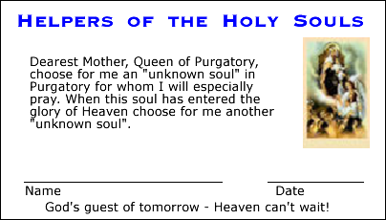
Pray for the Poor Souls in Purgatory Prayer Novena (Prefaced by a comment by St. Thomas Aquinas and St. Augustine on the other side)  http://www.poorsoulsprayers.com  Ron Gurba Jr.  P.O. Box 1  Harvey, Louisiana  70059  You can order them here:  http://www.poorsoulsprayers.com/order.html  50 — $7.00  100 — $9.00  200 — $16.00  300 — $20.00  400 — $25.00  500 — $30.00  100 — $50.00  All booklets are $2.00 each  Shipping and handling not included | IMPORTANT: Stipulation by Archdiocese of New Orleans Archbishop Alfred Hughes: "You must get pastor approval to put your Poor Souls Prayer Cards in any Catholic Church."  Please ask your pastor first, and also ask him if he knows of other priests who would love some cards.
An Optional substitute for The Fourteen Stations of the Way of the Cross with Meditations By St. Alphonsus Liguori  The Way of the Cross for the Holy Souls in Purgatory By Susan Tassone  Recall, reflect, remember, and pray.  Recall loved ones who have died and, in a spirit of true charity, keep in mind other departed souls who may have no one on earth to pray for them.  Reflect on the reality of Purgatory and those who, though so close to Heaven, must still prepare to enter it. These souls, the Church teaches, can benefit from your prayers for them, and their prayers, in return, can benefit you. | From Our Sunday Visitor: https://catalog.osv.com/  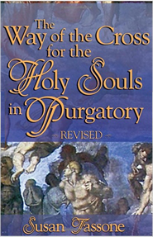  https://catalog.osv.com/Catalog.aspx?ProductCode=411

Interested in financially supporting our work?

Though the Lord has provided me with work, I am not making the big bucks that I use to.
A retail cashiering job at Target gives me the ability to just pay my monthly bills. That said, if you are interested in supporting this program, and financially can, there are three ways you can help:

- Donate to have Masses said for the Holy Souls in Purgatory.
Under the Having Masses said for the Holy Souls on Page 2 of this handout, we explain how we gather stipends for priests who, in turn, offer up Masses for the Holy Souls in Purgatory.
While we would encourage you to start doing the same at your local Catholic parishes, if you wish to support Brian Bagley’s efforts to do the same in his area, you can mail any financial support for stipends to:
Brian Bagley
Purgatory Prayer Program
62 Elm Street
Hopkinton, Massachusetts
01748
- Donate to support costly supplies in our prayer program for future Purgatory Prayer Program participants
There are three costly booklets/pamphlets that are in our Purgatory Prayer Programs. Ordering information for each can be found in the previous sheets labeled: Purgatory Prayer Program Supplies Sheets. The most costly to least are:

  - Daily Pilgrimage to Purgatory
  - The Fourteen Stations of the Way of the Cross with Meditations by St. Alphonsus Liguori
  - Novena & Chaplet to the Divine Mercy Leaflet
Depending on how the Spirit guides you, you can buy any quality of any booklet or pamphlet you wish and have them sent to Brian’s postal address above. Only send booklets or pamphlets to his address since I am the computer guy and do the on-line purchasing for our little group.
- Donate via PayPal or postal address to cover the cost of postage for the mailings or just to support the overall program.
Support with PayPal here:
http://www.helpersoftheholysouls.com/donate
Support via postal address here:
Mike Humphrey
132 Cedar Terrace
Apt. B
Natick, Massachusetts
01760

